*Florida International University*

*School of Computing and Information Sciences*

CIS 4911 - Senior Capstone Project

Software Engineering Focus

Feature Document

User Story #733

**Team Member:**

Andrew Mitchell

**Product Owner(s)**:

Francisco R. Ortega

**Mentor(s)**:

Francisco R. Ortega

...

**Instructor**: Masoud Sadjadi

**User Story –** Add Frames Per Second Counter

* As a User I would like to view the Frames Per Second so I can see the impact that certain devices have on the smoothness of the program.

Acceptance Criteria

* Add a FPS counter to the top right of the screen
* Must be toggle-able on and off.

**Use Case – View Frames Per Second**

Use Case

User launches application. User opens the ‘settings’ menu (located on the mode box). User toggles on and off the ‘Frames per Second’ button.

Details:

Actor: User

Pre-conditions:

Program must be running.

Description:

Use case begins when the user presses the ‘Frames per Second’ button located in the settings menu. The user can toggle it on and off at will.

Post-conditions:

The program should write the FPS in the top right corner as black text.

Decision Support:

Frequency: Often. It is a very good developer tool to see how the program runs and its efficiency, especially when used by different people using multiple devices at once.

Criticality: Medium. It is a nice feature for testing, great for developers and the openHID lab.

Risk: Low. Implementing an FPS tracker is fairly simple, we simply have to add a chrono check and do some division, as well as setup a new button.

Reliability: Highly.

Mean time to Failure – N/a. The button should always bring up the FPS.

Availability – If the mode box is available.

Performance:

Should have very lower performance impact.

Supportability:

Entire Program and all devices.

Supported by LibUSB – version 1.0

Modification History:

Owner: Andrew Mitchell

Initiation date: 4/4/2016

Date last modified: 4/4/2016

**Use Case Diagram**

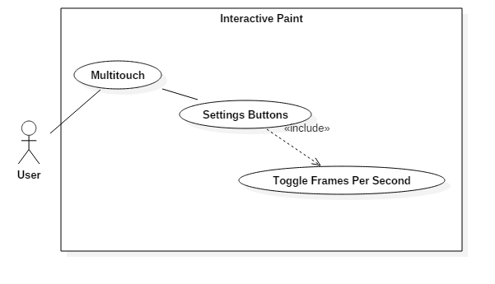

**Sequence Diagram**  
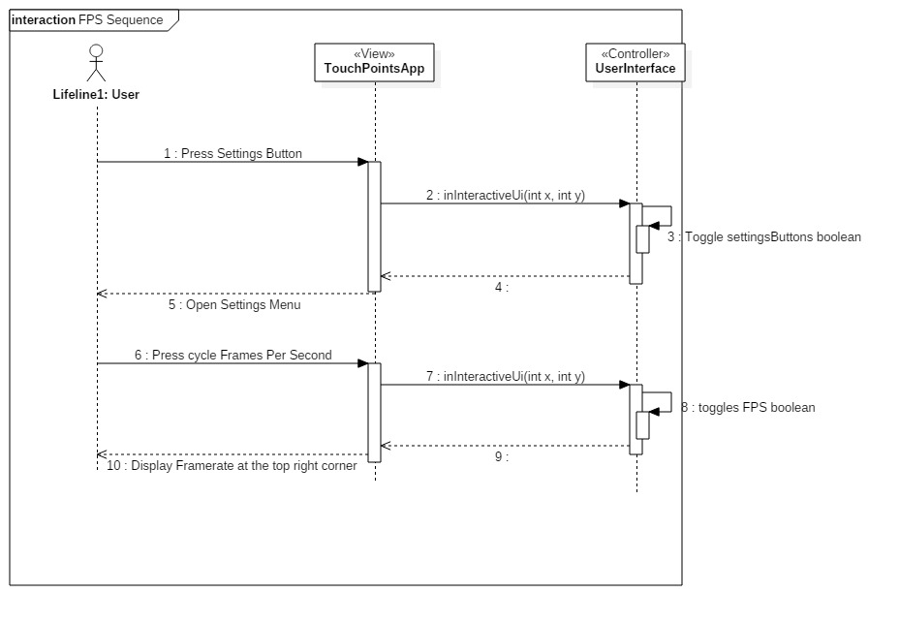

**Class Diagram**

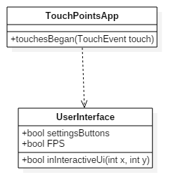

**Unit Test**

Sunny Day:

Test Case: Toggle FPS

Test Purpose:

Ensure we can toggle FPS on.

Test Setup

1. Start Program
2. Open settings menu.
3. Press ‘Frames Per Second’
4. View FPS at top left corner

Test Output:

The top right corner displayed ‘Framerate: 49’ and changed slightly every once in a while.

Expected Output:

It should display the words ‘Framerate’ in the top right corner, followed by a number that will chance frequently.

Rainy Day Tests:

Test Case: Toggle Off FPS

Test Purpose:

Make sure the user can toggle off FPS if he doesn’t want it anymore.

Test Setup:

1. Start application
2. Press Settings button
3. Press ‘Frames per second’
4. Press ‘Frames Per second’ again.

Test Output:

After step 3 the FPS showed up. After step 4 it disappeared.

Expected Output:

Every touch of the ‘Frames Per Second’ button will toggle the appearance of the FPS counter. 3 Should bring it up, while 4 will make it go away.

**Integration Test**

Currently works with the multi touch plugged in only.

It is integrated with the settings button Menu.

Currently when FPS is turned on, all functionality remains. Including drawings etc.

FPS is integrated to show FPS of the whole program, this way we can see how performance is impacted by different devices.

Devices tests

Real Sense – Most impact

Leap Motion – Second most Impact

EyeX – Third most impact

Multitouch Device – Least Impact (unless drawing)

**User Guide**

To enable the FPS tracker you first must click the settings button located at the bottom left of the mode box.

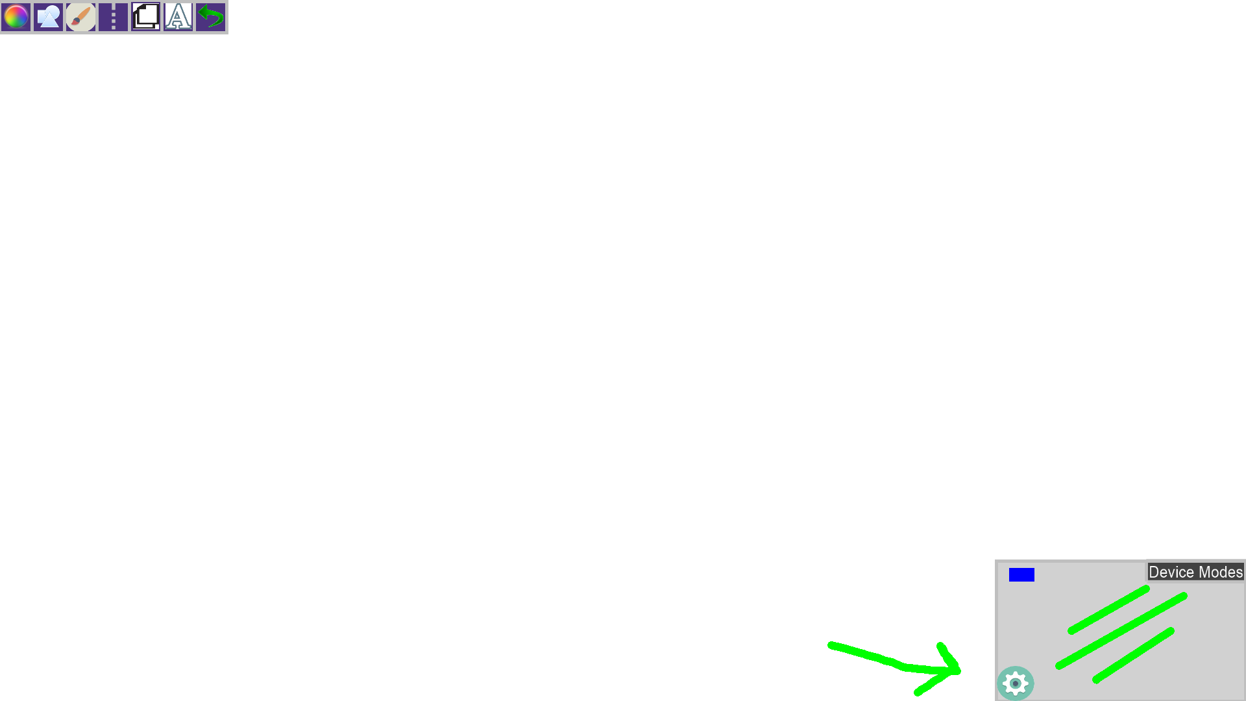

After that you can click the ‘Frames Per Second’ button to enable frames per second in the top right corner. This will display how many frames you see per second. This is useful when using various devices because you can see how much impact performing certain tasks has on the responsiveness of the system.

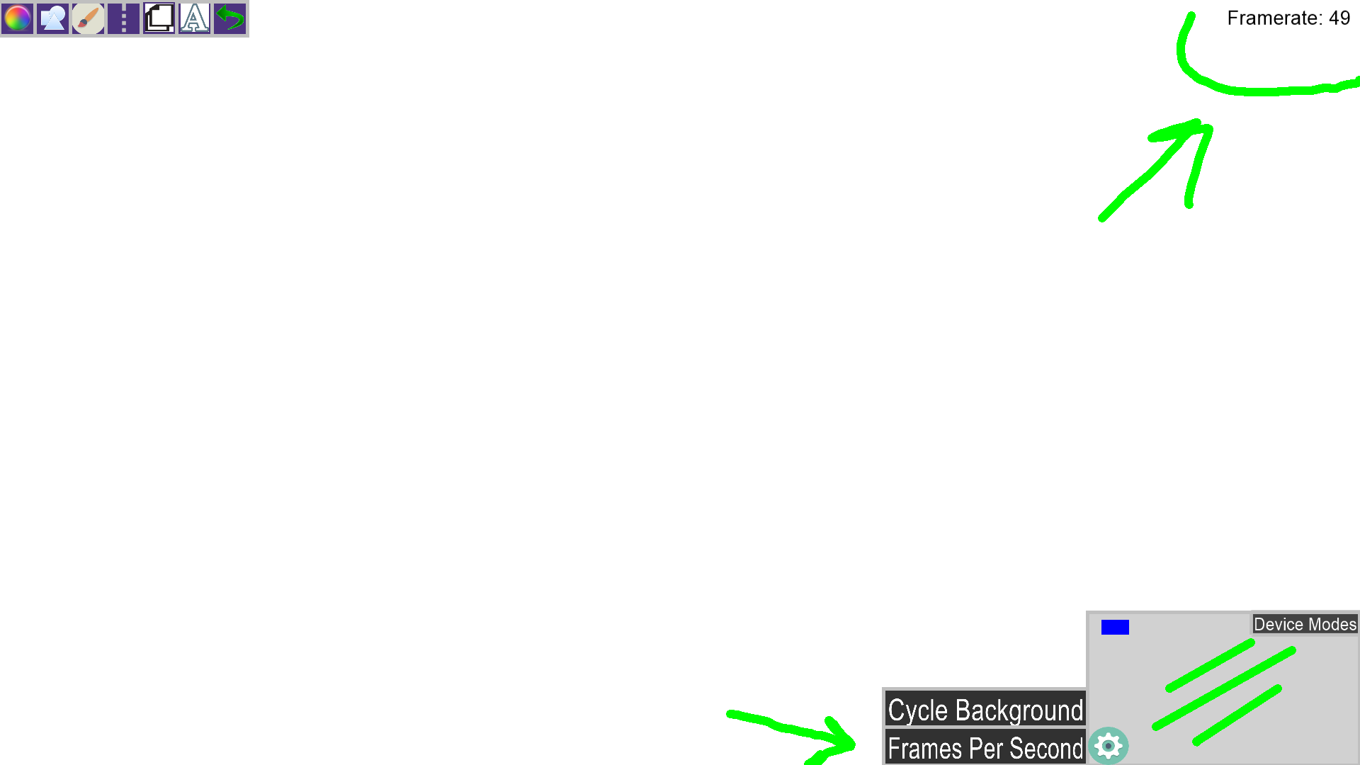

**Glossary**

FPS – Frames per second – how many frames the program displays every second.

Chrono – a C++ Library that helps you interact with the system clock.